Events in the Park- Friends of the Wickford Memorial Park- Volunteer Group
Continuing articles on the Wickford Memorial Park- this month we will be looking at what goes on in the park and the various events that the ‘Friends Group’ run.
The ‘Friends Group’ is more than a pure gardening group. We run lots of events throughout the year aimed at promoting our lovely park and organising lots of different events for our volunteers and visitors.
The volunteers are a friendly group, and have organised a number of social events for them. We have a Christmas Thank You Event in December and have had afternoon teas to get together.
A very successful fundraising Quiz Night was run in July, which proved very popular amongst the Group and their friends and families. Another will be planned sometime in 2024.
This year we joined the RHS Hyde Hall as an Affiliated Group which enabled us to take up to 55 members for a visit to Hyde Hall. It was a lovely day out.
One of the most well attended Events was our evening Bat Walk in August, for which over 50 people attend. It was a warm, clear night and we saw lots of bats and heard them on sonar equipment supplied by our expert ‘bat man’ Frank Street. He was a font of knowledge, and it was fascinating to hear all about the different species of bats in the park.
We will definitely run another one!
We also run Easy Walking Tours of the Park which includes a talk on the history of the park and explanation of the work that the Friends are involved with. We have also given presentation talks on the park at St Andrews Church and the Wickford Horticultural Society, both of which proved very popular.
We manned a stall at the Community Showcase Day, with a Tombola, we had a very successful day and networked with other Community Groups in Wickford.
During the Summer our work in the park is normally focussed on watering and weeding the well established beds and borders. Our main tasks for Autumn into Winter will be;
Mulching the Orchard
* Planting Bulbs- everywhere
* Replanting the Raised Bed in the Home Front Garden
* Hosting an Open Day for the New Reflection Garden
* Poppy displays around the Memorial Trees and Knitted Poppy display
for the Beacon, in time for Remembrance Weekend.

Please look out for future events on Facebook using the Events Tab

We run our gardening groups every Wednesday and Saturday mornings if you’d like to come along, no gardening experience necessary and there are tasks for all abilities.

There are three car parks: Runwell Road (main entrance); Rettendon View and Highcliffe Road.

Please visit our website: www.friendsofwickfordmemorialpark.co.uk
Or Facebook: Friends of the Wickford Memorial Park

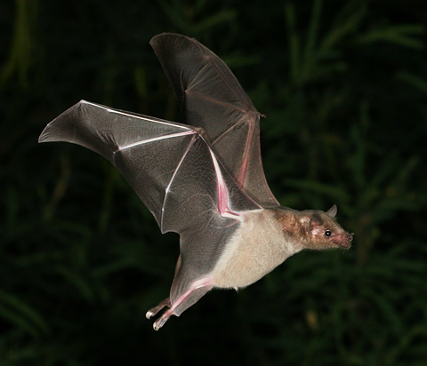
Bat Walk Event
Visiting RHS Hyde Hall

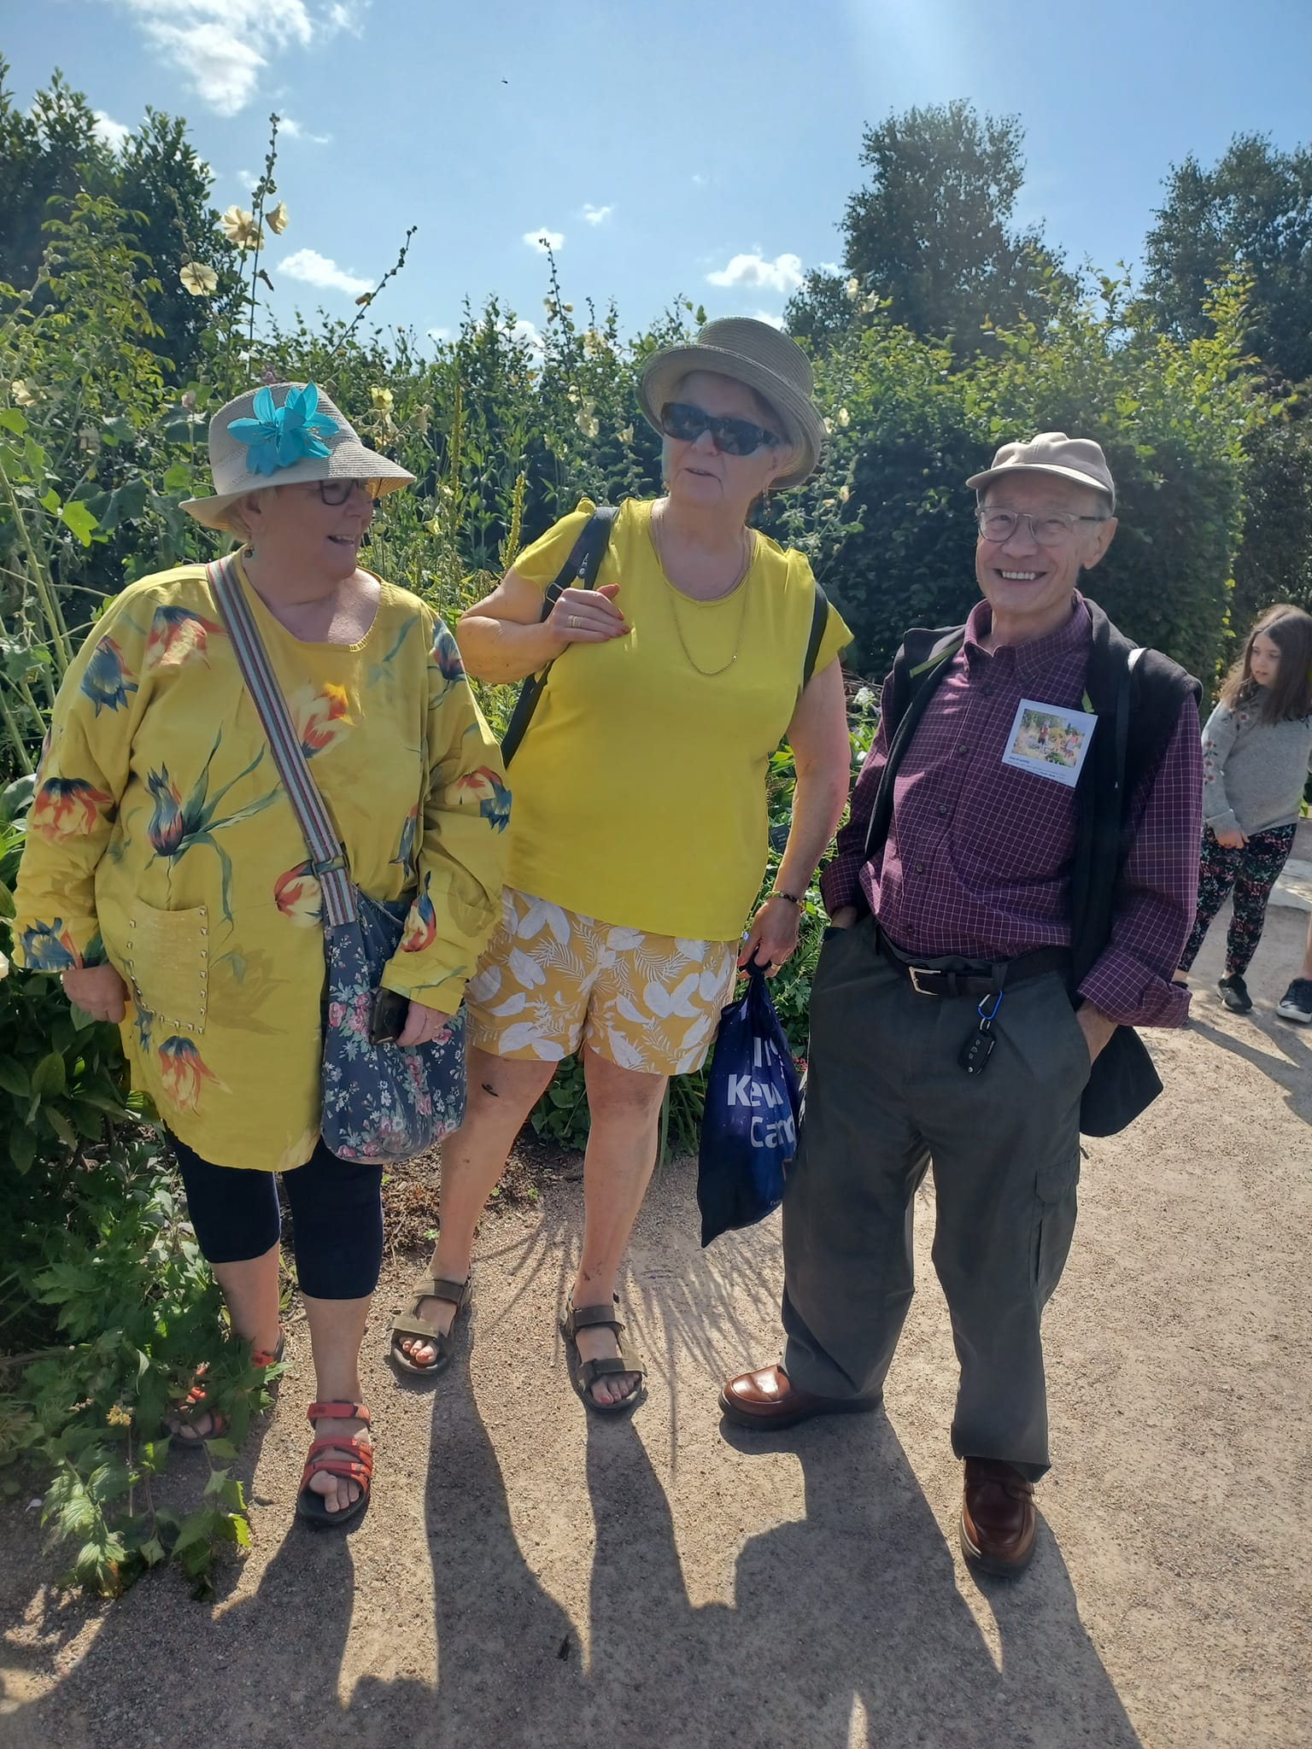
Visiting RHS Hyde Hall

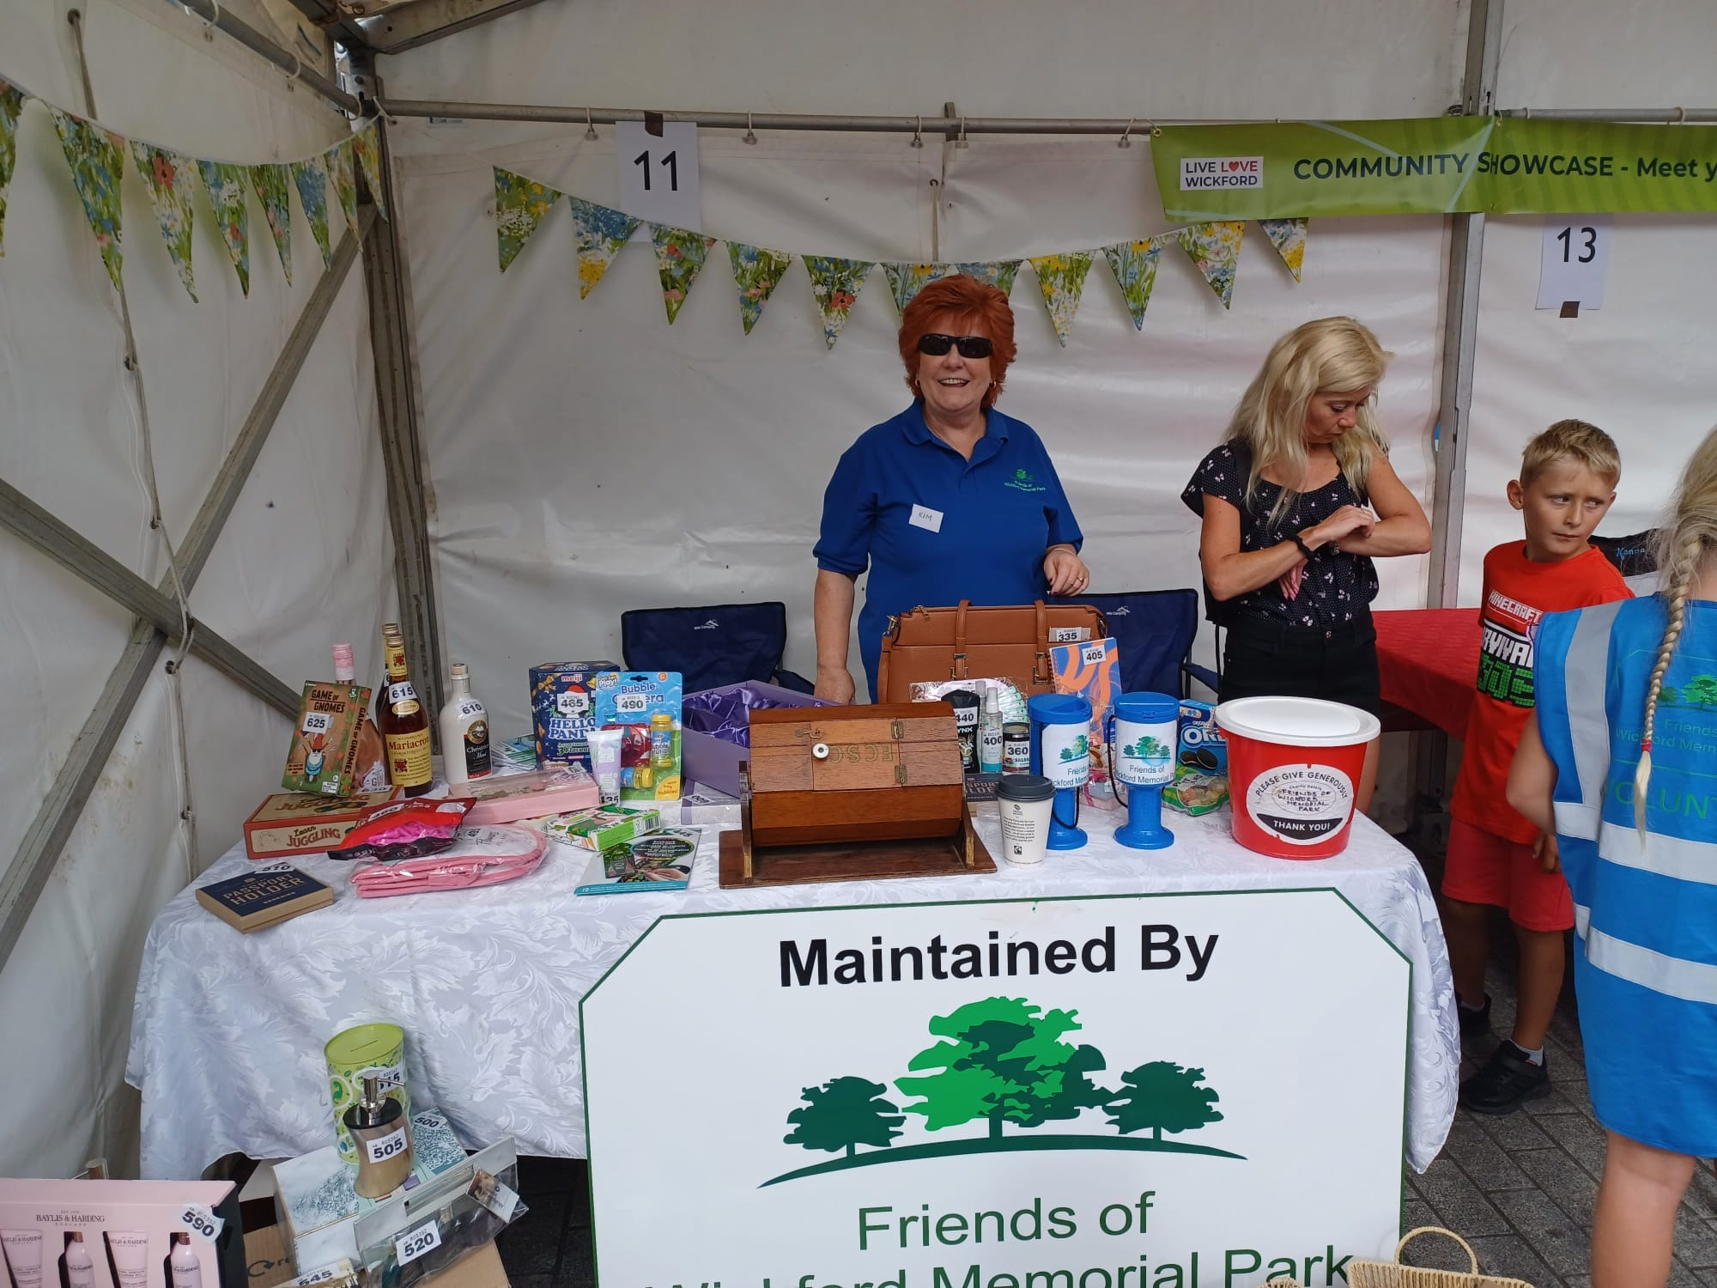Community Showcase Day

Q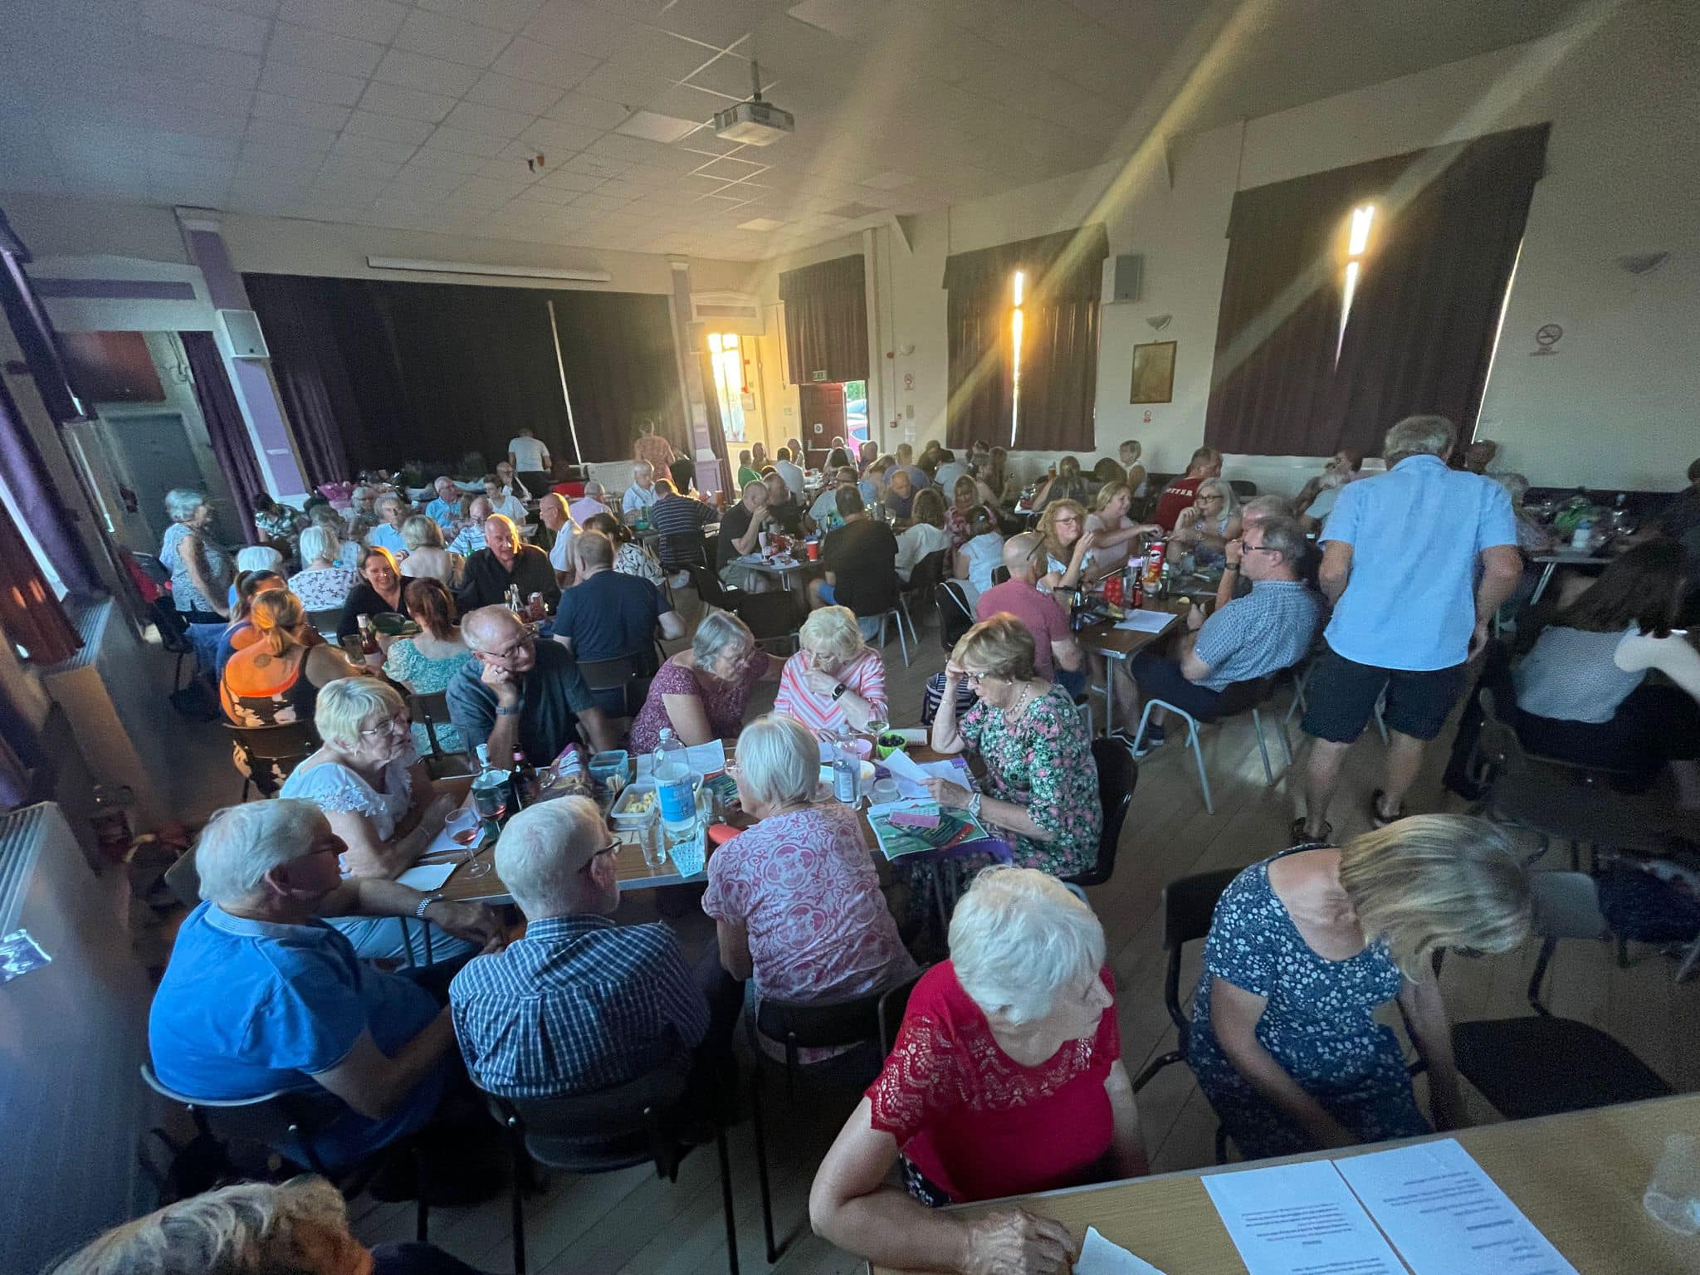Quiz Night

