Wickford Memorial Park – War Memorial, Heroes Arboretum, Remembrance Ave
January’s edition of the magazine gave an overview of the Wickford Memorial Park and the volunteers group.
Over the months we will be breaking down areas in the park with more information.
This month we are looking at three areas as you come into the park from the main Runwell Road Entrance. There are three car parks: Runwell Road (main entrance); Rettendon View and Highcliffe Road.
War Memorial
The War Memorial is situated just outside the main gates in Runwell Road Entrance. The Memorial itself was built and moved into place November 2011.
Every year the Remembrance Parade is held at the Memorial.
The Friends Group have planted the borders of the Memorial and planted thousands of daffodils leading to the main road.
Heroes Arboretum
This area to the right of the main gates is dedicated to venues where servicemen have fallen and the site of the Beacon.
These commemorative trees have been planted in remembrance to the Wickford men who sacrificed their lives in World War I., there is an information board by the Beacon.
Arboretum will be a lasting tribute to their courage and determination. Each tree represents a battle of campaign where the men fell.

The Friends Volunteers have planted thousands of bulbs in the area across the back and around each tree and wildflowers at the base of the wall.
We have also refurbished two benches, which have been installed by the council and Carter and Ward erected a black mesh along the back fence to hide their compound.
The Beacon
The Beacon was installed inside the main gates in time for the Platinum Jubilee celebrations.
The Friends Group helped co-ordinate the flower tributes for the Queen funeral.
We expect it to be lit again for the Coronation in May.
The shrubs and plants inside the Beacon area were planted by the Friends Group.
Remembrance Avenue
The Remembrance Avenue is a tree lined pathway, each tree dedicated to a fallen serviceman.
Each tree has a plaque. Full details of the history of them can be found on the Wickford War Memorial Association:
Wickford War Memorial Association - Home (wickfordmemorial.com)
(They maintain the records of the servicemen and women, plus civilians that died in the wars.)
Please visit our website: www.friendsofwickfordmemorialpark.co.uk
Or Facebook: Friends of Wickford Memorial Park

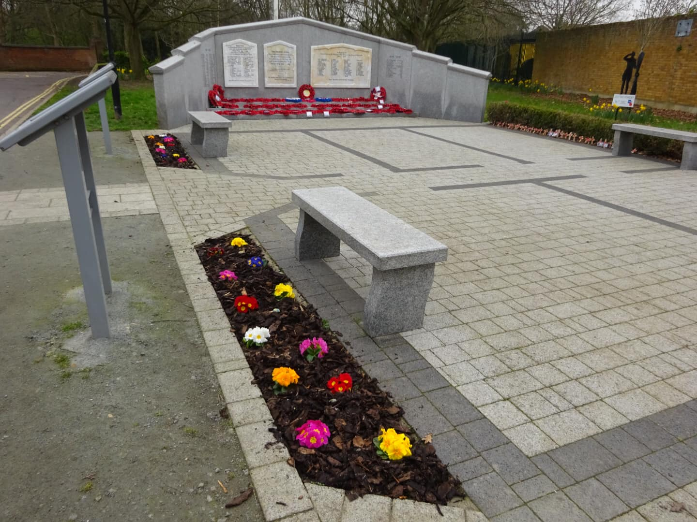
War Memorial
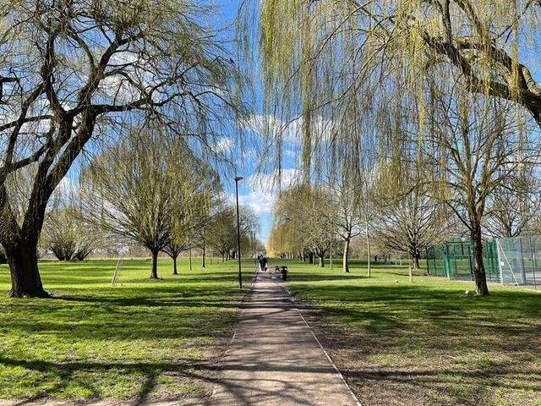
Remembrance Ave
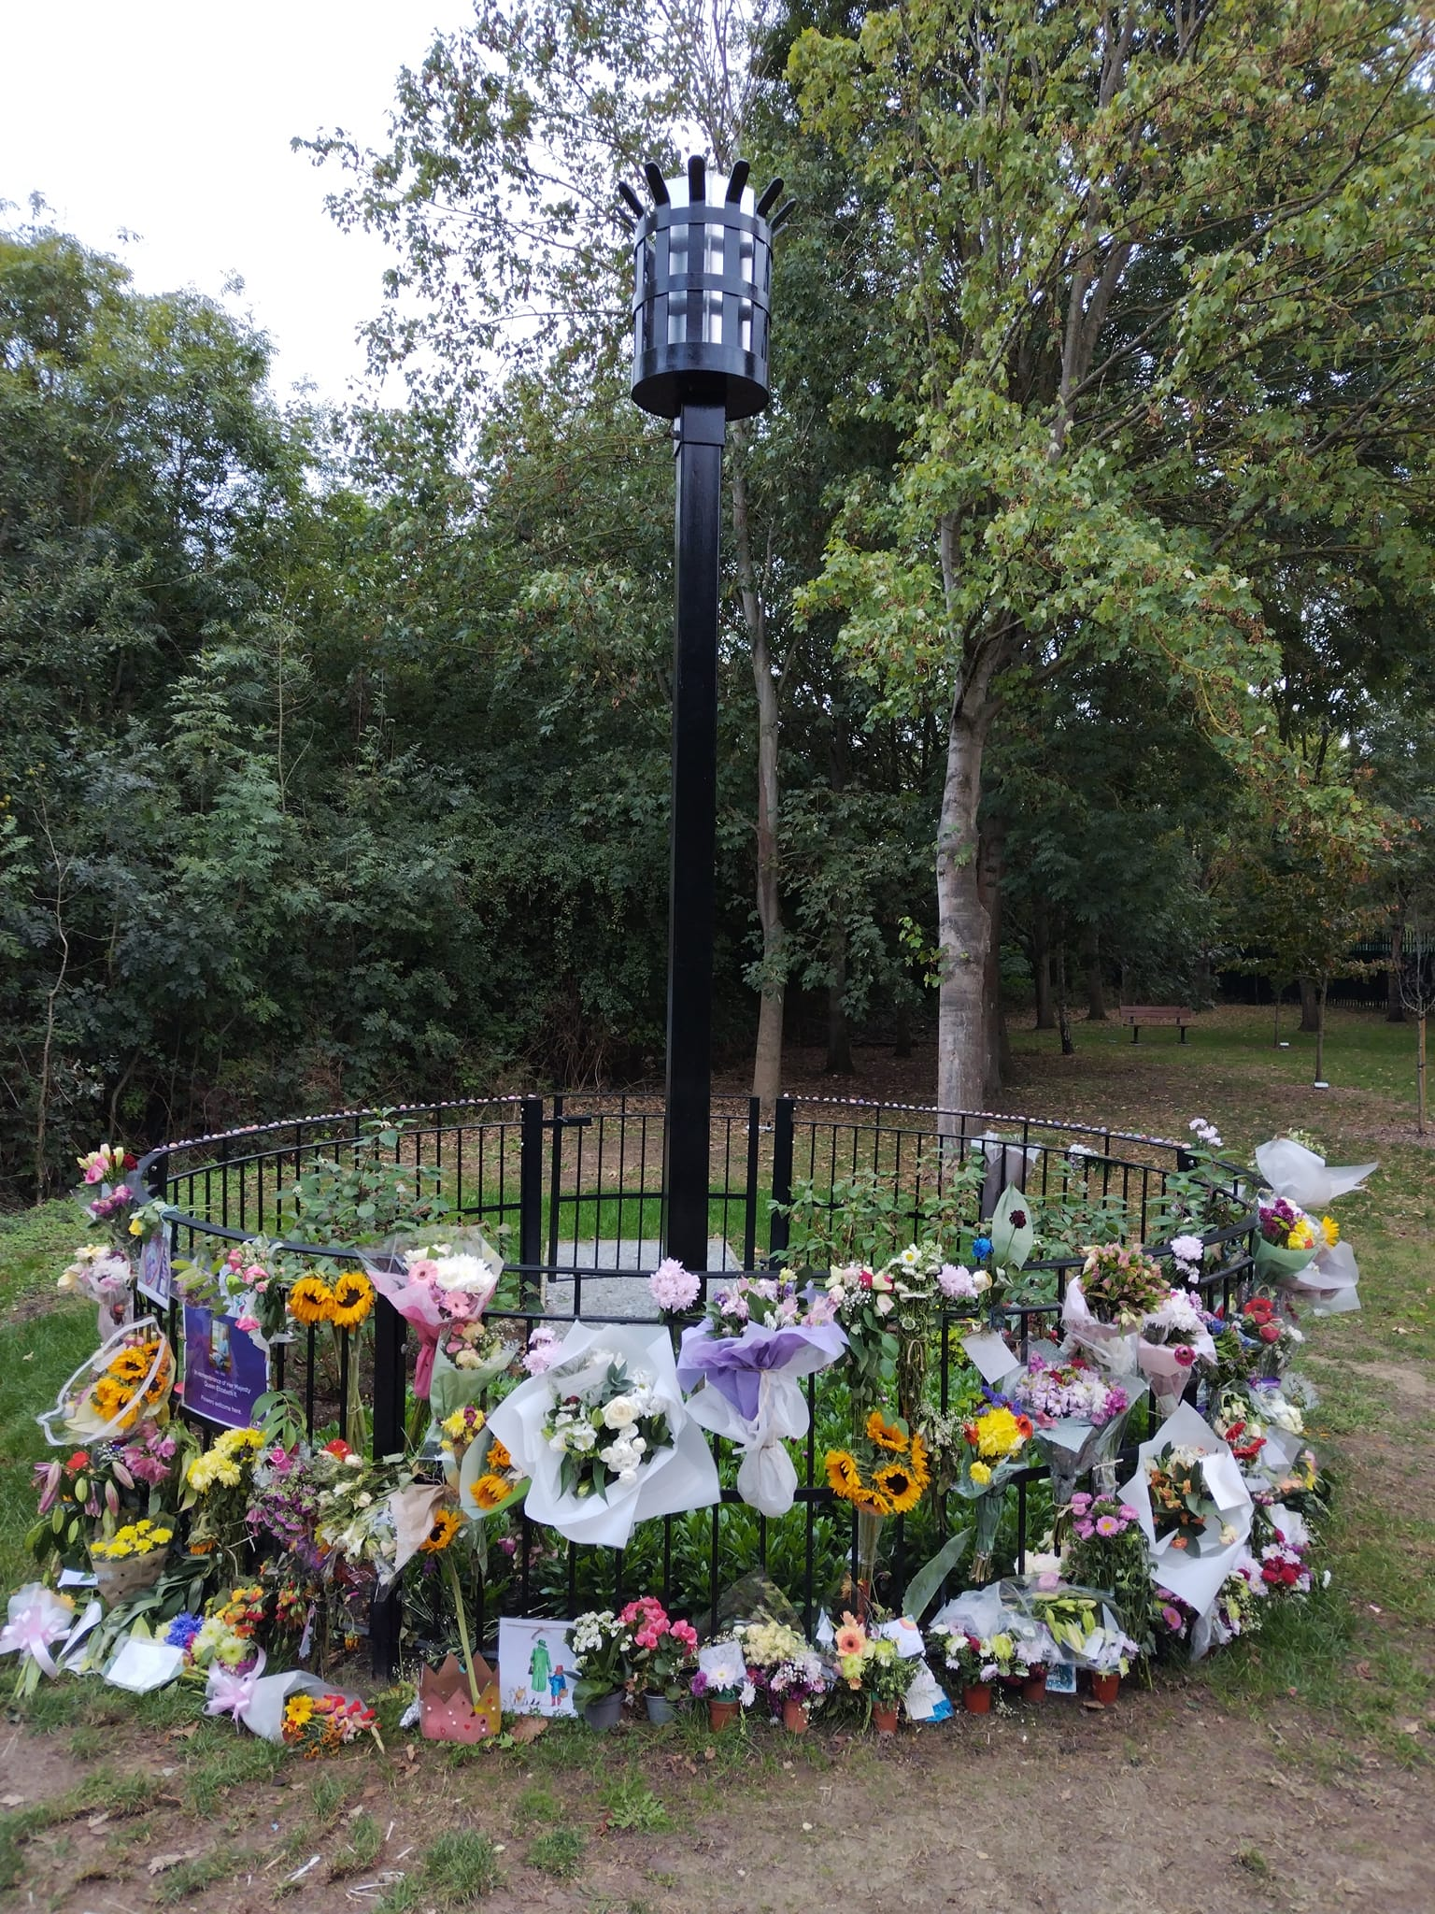
Beacon with Floral Tributes

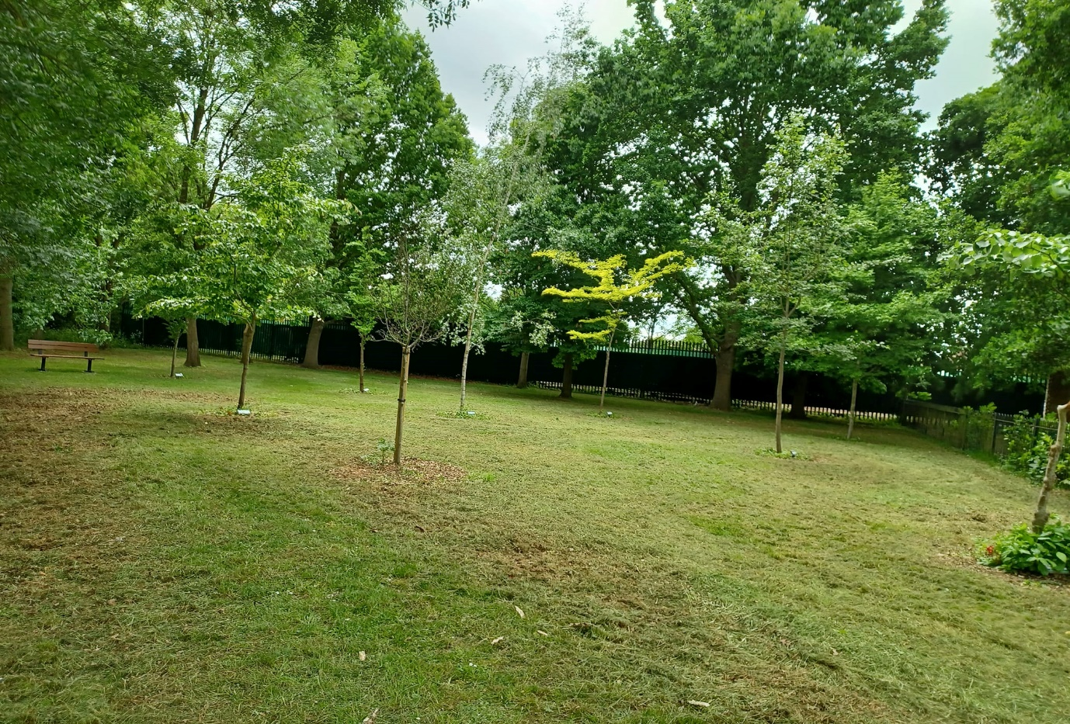
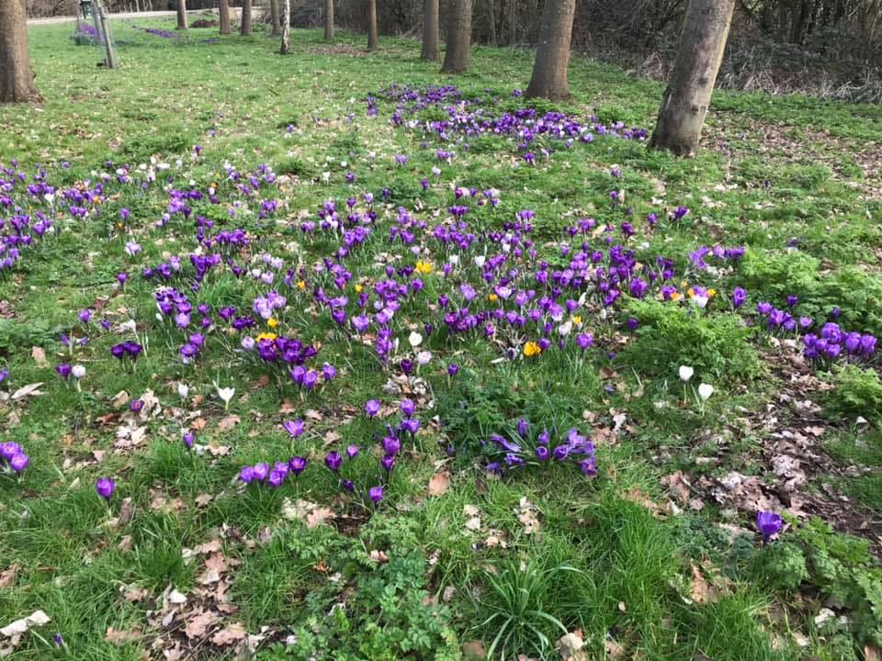
Heroes Arboretum

