Friends of Wickford Memorial Park- Volunteer Group

Friends of the Wickford Memorial Park is a constituted volunteer group with a committee.
We formed to look after the park in October 2019. The park is over 112 acres of green belt land, and we need to protect and develop this fantastic asset. This includes the new Beauchamps Meadow, 26 acres of land which is being developed into a nature reserve.
We have our own lock up within the council compound and work closely with the park management in helping develop many projects in the park including our pièce de résistance- The Home Front Garden.
In 2019, this garden was unkempt and completely overgrown. We planned, bulldozed, and replanted it from scratch.
We have been running gardening work parties since October 2019 and have regular weekly gardening groups on Wednesdays and Saturdays from 9:30-11am. Everyone is welcome to join and there is no obligation to come every time. We are a friendly bunch of people, and you would be made most welcome.
All our volunteers agree that the park is a special place and its wonderful for your wellbeing.
We are much more than a gardening group now and we have lots of ideas and projects for the future. We have planted nearly 5,000 English bluebells; 14,000 Narcissus, Crocus, Snowdrops, Cammassia, Nerines, Allium, Hydrangeas; refurbished the Crazy Golf and built Bug Hotels and bird boxes.
We have planted over 400 trees/whips to extend the Jubilee Wood; 22 mature trees on the new Parkland Amenities area; helped plant 3500 trees with the Woodland Trust on the New Beauchamps Meadow woodland area plus 300 whips to make a wildlife habitat.
New projects include a new Reflection Garden, the first phase has recently been planted with 15 mature Silver Birch Trees, Mid-Winter Fire Dogwoods, Hellebores and 1000’s of Crocus and Snowdrops.
The second phase will be in the new year.
The Reflection Garden is funded by the National Lottery Community Fund, who kindly granted us £9,450.
Also planned for 2023 is the Community Orchard, which forms the last phase of the Basildon Councils Parks and Countryside vision for the Beauchamps Meadow. The Friends Group have been asked to help with the planting of 200 native fruit trees including: Apple, Crab Apple, Pear, Plum and Cherry.
We also run informative and fun tours of the park, please look out for the next one in the New Year.
Please visit our website: www.friendsofwickfordmemorialpark.co.uk
Or Facebook: Friends of Wickford Memorial Park
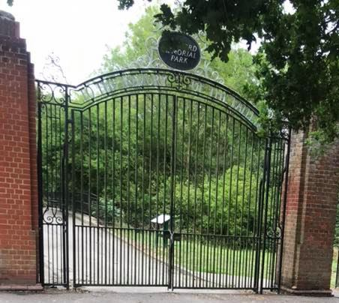Main Gates
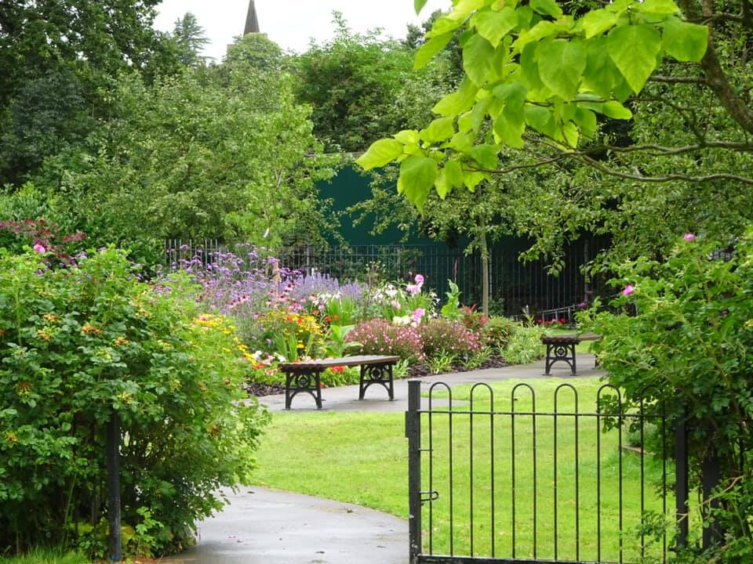
Home Front Garden Entrance
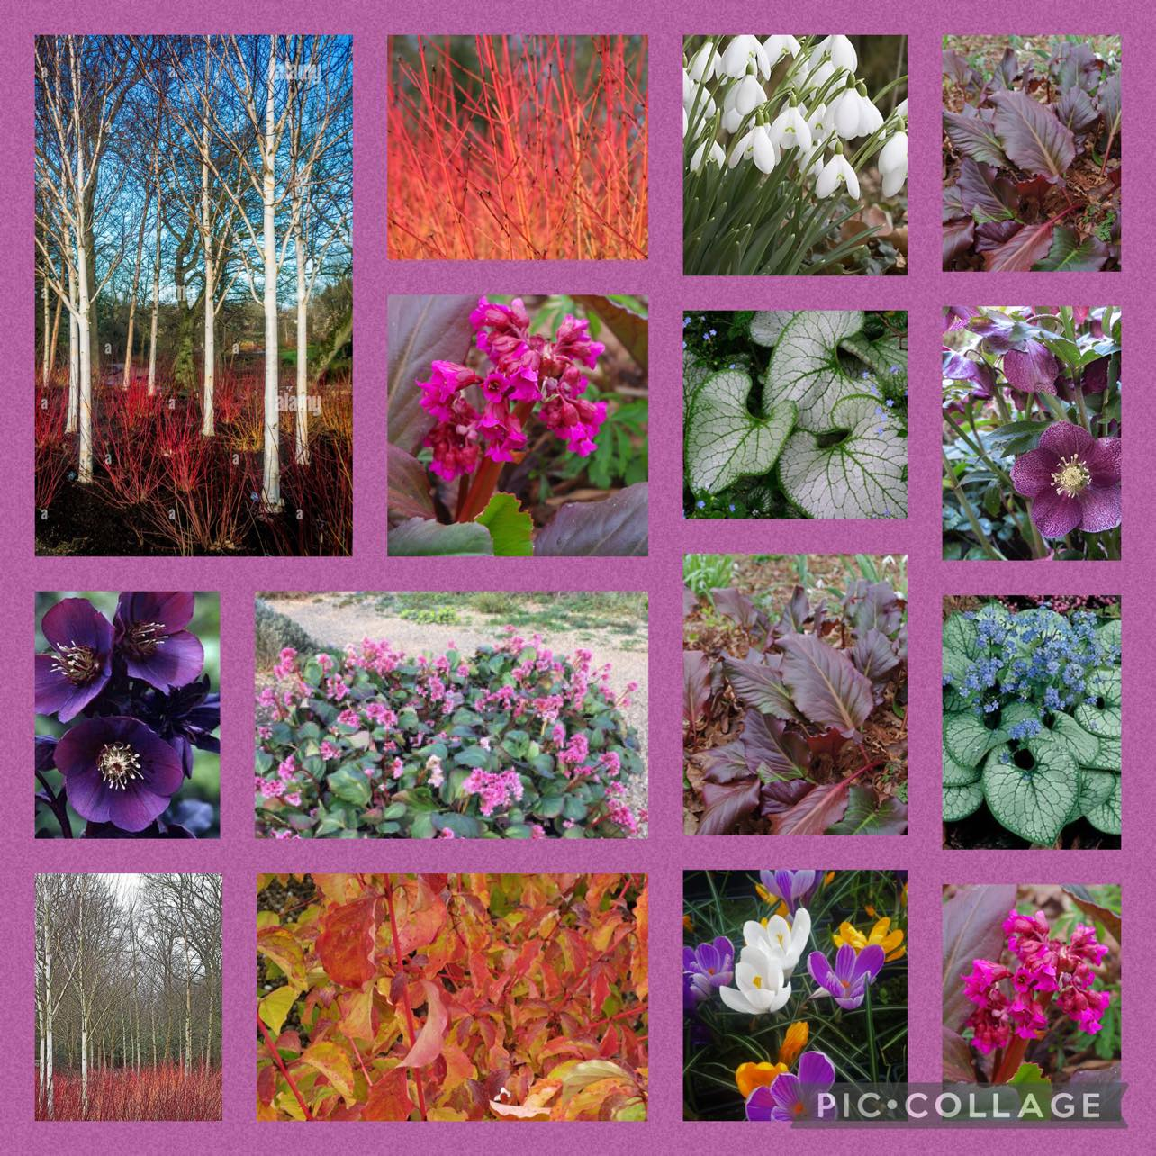
Reflection Garden Planting Plan
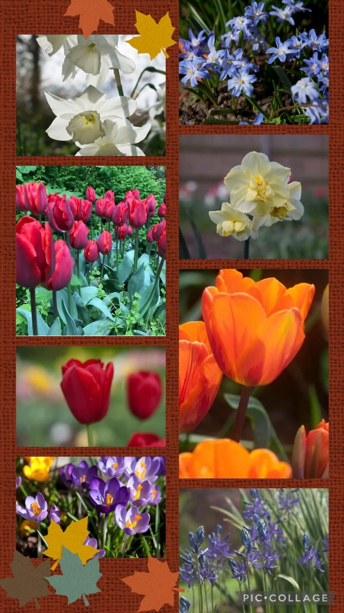
Bulbs in the Park

