Friends of Wickford Memorial Park- Volunteer Group
Continuing on our tour of the Memorial Park- this month we will be breaking down more areas in the park with more information.
We will be looking at Huttons Café, The Crazy Golf and the ‘Spring Mound’.
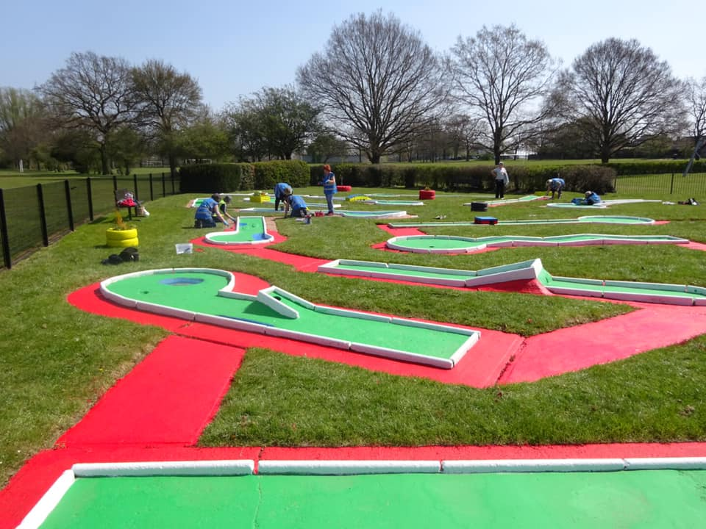
Hutton’s Café
Hutton’s Café is situated by the Rettendon Ave Car Park. (by the Childrens Playground)
It is open everyday except Mondays for breakfast, snacks, lunch afternoon tea etc.
They also hire rooms and cater for events.
The volunteers love Hutton’s and we socialise after our gardening groups for lunch and coffee.
The staff have been very kind and helpful to the Friends Volunteers.

Crazy Golf
The Crazy Golf was built in the 1970’s and was falling into disrepair when the Friends Volunteer Group was formed in 2019.
Working with the council staff we refurbished two reclaimed benches and they were installed in the Crazy Golf Area by the council contractor.
Also we cleaned and painted reclaimed tyres, car and tractor tyres for ‘planters’ in the Crazy Golf. Again these were installed by the council contractor.
The Crazy Golf was repaired and the Friends sealed and painted all the eighteen holes. It was a mammoth task and we arranged for Team Building Days with Fords to help, seal, paint and edge the holes.
The Friends Group planted Spring bulbs and shrubs in the planters and around the Crazy Gold area.

There are three car parks: Runwell Road (main entrance); Rettendon View and Highcliffe Road.
Please visit our website: www.friendsofwickfordmemorialpark.co.uk
Or Facebook: Friends of Wickford Memorial Park

